Architecture and zoning

What’s the range of electric vehicle

Fear of lacking charging stations

Several types of charging stations

There are 3 main types of charging stations:

_ level 1 : AC level 120 volts, generally 15 or 20 ampere. It is the cheapest type of charging stations, but requires a lot of time to charge any car. Due to the long charging time (>8h), this type of charging station is mainly used to charge its vehicle overnight, at home.

_ level 2 : AC level 208-240 volts, 40 ampere (80 maximum). This intermediary charging station is a bit more expensive, and can be used in commercial areas, or any other place where the driver will stay a limited but still not too short amount of time. It is expected to fully charge a vehicle in between 4 and 8 hours.

_ level 3 (fast charger) : DC power converted from AC power up to 480 volts. Far more expensive, this charging station enables the driver to charge its car to 80% in 30 minutes.

  

Level 1 EV supply equipment Level 2 EV supply equipment DC fast charger

(doc NYSERDA p3)

Although the plugs for level 1 and level 2 charging stations are the same, the DC fast chargers has currently two different standards for the plugs.

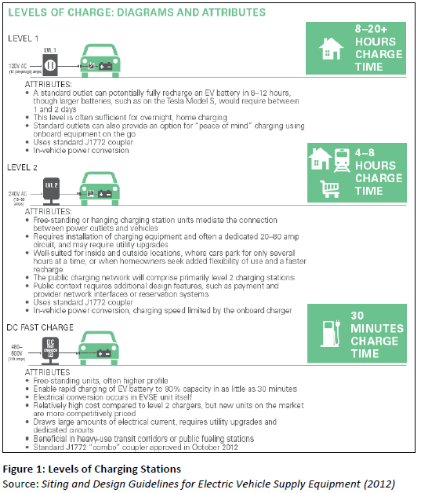

Rules and design to put charging stations

Charging stations need to fit in the current environment, whether it is in private areas (home garage), or public areas (parking spots). At this time, many rules about the design of such charging stations have been implemented; they specify the required size, the security of the charging stations, the minimum number of charging stations in an area. There regulations are more mature in Europe and the US, and we will consider here the US regulations. Although many of these rules are local and depend on the city, we can find the same characteristics.

Design of the parking spot:

_ the charging stations is generally at the front or the sides of the vehicle; what’s more, the user need to be able to operate it, which requires extra place at the front of the vehicle. Extra place on the side should also be arranged to deal with the issue of the cable (a level 2 EV station has a cable of a length around 20 feet). In many high density parking areas, built before the use of charging station, the design of the parking spots is not adapted to these new constraints.

 

**Striped pavement designates space to operate EV supply equipment Cables can create tripping hazard**

Account Many DC fast charger are designed differently because they are heavy. But these kinds of design could have an impact on the ergonomics of parking spots. Some parking structures provide opportunities for a more practical and cost-effective design.

 

**Suspending cable assists with handling Ceiling--‐mounted conduit located near wall**

_ in parking facilities, the localization of the charging stations needs to be chosen: is it better to place them near the entrance of the shopping mall (ie among the most frequented places) or a bit further? Near disabled people spots (already designed to be larger) or not?

_ When choosing a place to put the charging station, one need also to take into account the need to connect it to an electrical source. It could be solar panels, but it can also be the public electricity network. In this fashion, the need to trench into the ground to connect the charging stations is also an issue in parking areas.

_ The security of the charging station place concerning the environmental risks is non neglectable. It should not be installed in flooding areas. It should be protected from the shocks of a vehicle for instance, or any other hazards.

 

**Use of wheel stops to prevent vehicles**

**Wall--mounted barriers offer an alternative**

**to wheel stops and bollards**

**from damaging EV supply equipment**

_ another issue for the charging stations is that most of the stations, at least in public areas, are going to be connected with modems, in order to give information such as whether or not the charging station is occupied for instance. In some places like parking spots in basement, it will be a challenge to guarantee a good network. In these kind of stations, the connection to the network is necessary to use the charging station.

_ finally, the use of adapted signalization and databases is important to be able for every user of electric vehicle to locate a free charging station nearby.

Necessity of an electrical infrastructure:

In order to provide with electricity, the source of electricity should be considered. In a home garage, it will not raise any difficulty because it is possible to connect the charging station to the home electricity network. By the way, this is very relevant because it could be used for smart grid applications. However, in other types of areas like parking spots, the connection is not so simple.

Different locations for different purposes

The Range Anxiety effect

Many researches have been conducted to see what the average distance a vehicle moves every way. It has been shown that 95% of the days, the mileage does not exceed 100 miles, which makes most of the daily commuting possible without the need to charge an electric vehicle during the day (only at night at home is enough). 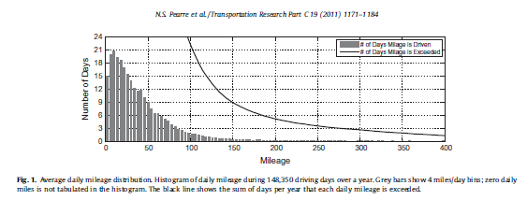

(source : Pearre, NS[, Kempton, W](http://orbit.dtu.dk/en/persons/willett-kempton(ea441340-0ac8-4cc7-91aa-29c49caff36f).html), Guensler, RL & Elango, VV 2011, '[Electric vehicles: How much range is required for a day’s driving?](http://orbit.dtu.dk/en/publications/electric-vehicles-how-much-range-is-required-for-a-days-driving(9cc2a01c-d05b-4d92-a658-8be44a828d7e).html)' [Transportation Research Part C](http://orbit.dtu.dk/en/journals/transportation-research-part-c(c8a547b1-cdf9-40c8-98d8-5b38f74393e4).html), vol 19, no. 6, pp. 1171-1184., [10.1016/j.trc.2010.12.010](http://dx.doi.org/10.1016/j.trc.2010.12.010) )

Yet, many people today refuse to use electric vehicles because they fear they will run out of battery. This is called the range anxiety.

Conclusion:

In this part, many elements should be taken into account :

_ the fear of a desert of charging stations

_ the different size of cities and availability of parking areas

_ the need near the charging stations of electrical infrastructure